ICC Cricket World Cup Match Winner Prediction
Technical report for a binary classification project predicting whether Team 1 wins an ICC Men's Cricket World Cup ODI match. Data sourced from Cricsheet.

1. Introduction
Cricket World Cup matches attract huge global interest, and pre-match forecasting is a classic machine learning use case. We frame winner prediction as binary classification: given pre-match information (teams, venue, toss, historical form), predict team1_won (1 if the first listed team wins, else 0).
The dataset contains 257 completed World Cup ODIs from Cricsheet's ICC Men's Cricket World Cup archive (1975–2023 era). The target is moderately balanced (61.1% team1 wins).

2. Preprocessing & Exploratory Data Analysis
Raw JSON files were parsed into a tabular match log. Matches without a decisive winner (no result / abandoned) were removed. Team names were standardized, dates parsed, and chronological rolling features were engineered using only past results to avoid data leakage.
01 Target Balance:
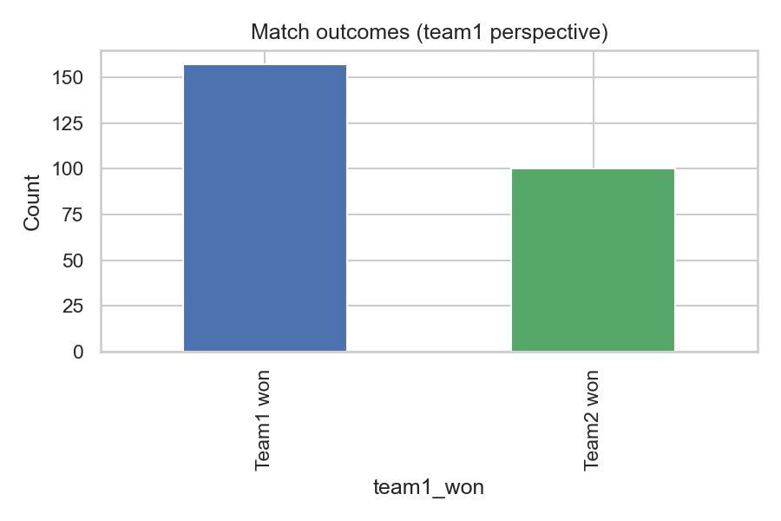
02 Matches By Year:
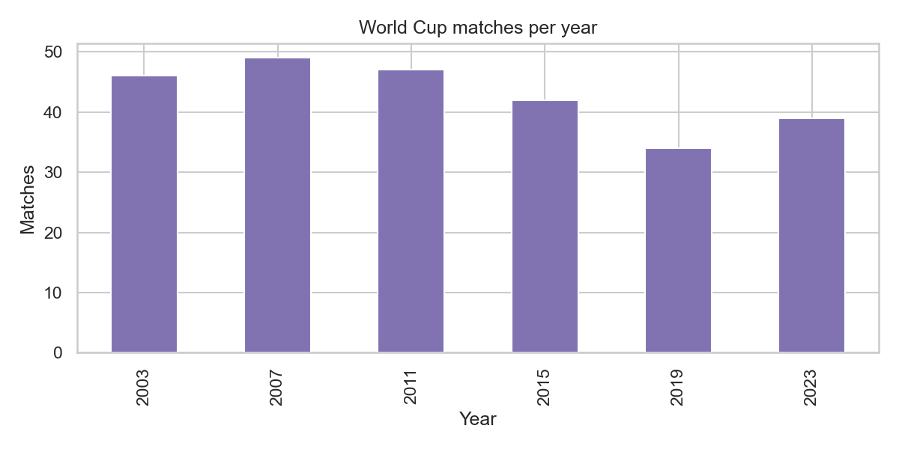
03 Top Venues:
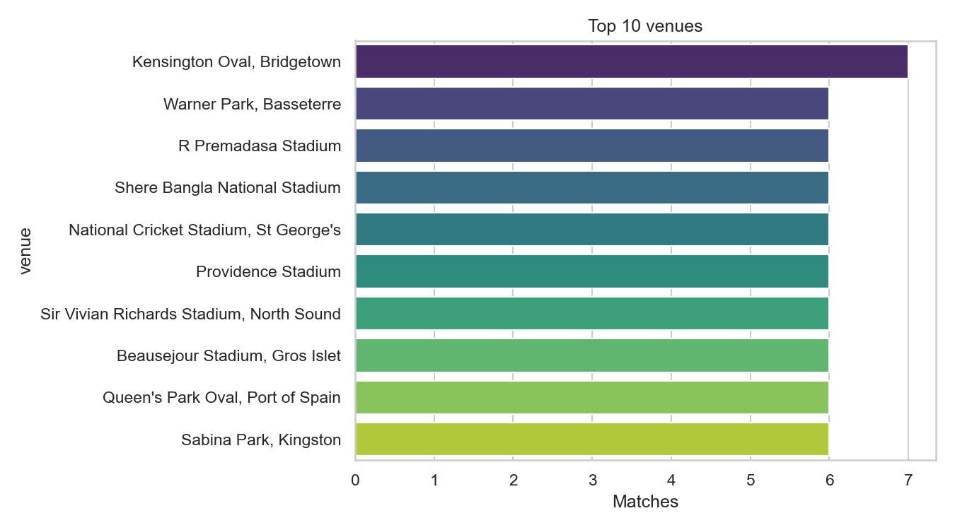
05 Correlation Heatmap:
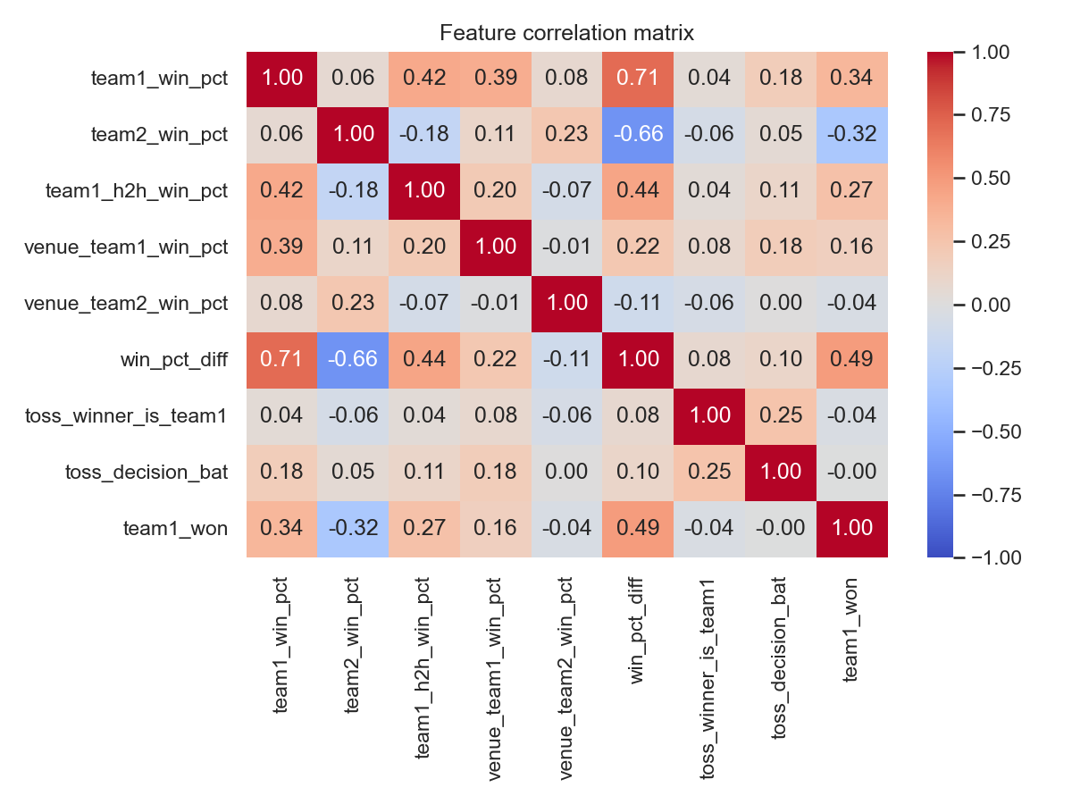

3. Methodology
Features include team rolling win percentages, head-to-head win rate for team1, venue-specific win rates, toss indicators, year, and one-hot encoded team/venue identifiers. An 80/20 stratified train-test split was used. Three models were compared: Logistic Regression, Random Forest, and XGBoost.
Training samples: 205 | Test samples: 52

4. Results
Best model: Logistic Regression
Accuracy: 0.846
Precision: 0.900
Recall: 0.844
F1-score: 0.871
ROC-AUC: 0.817
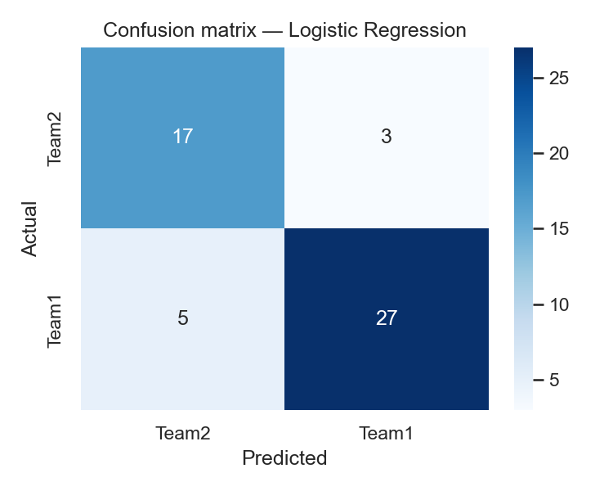
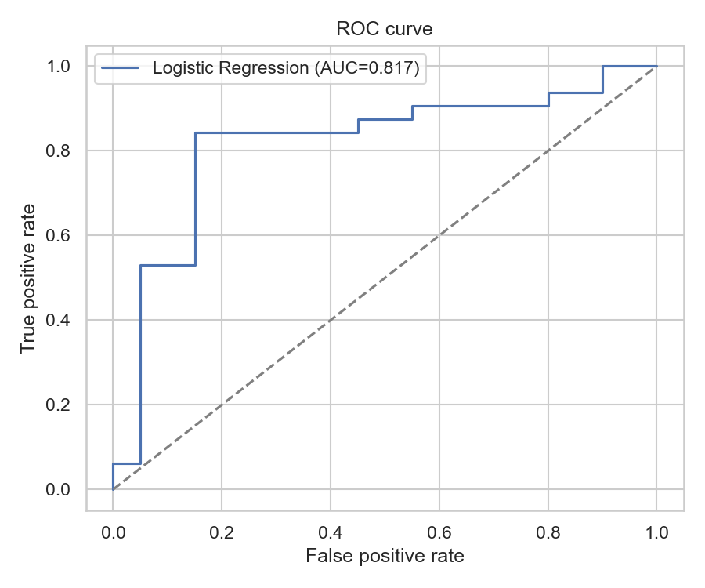
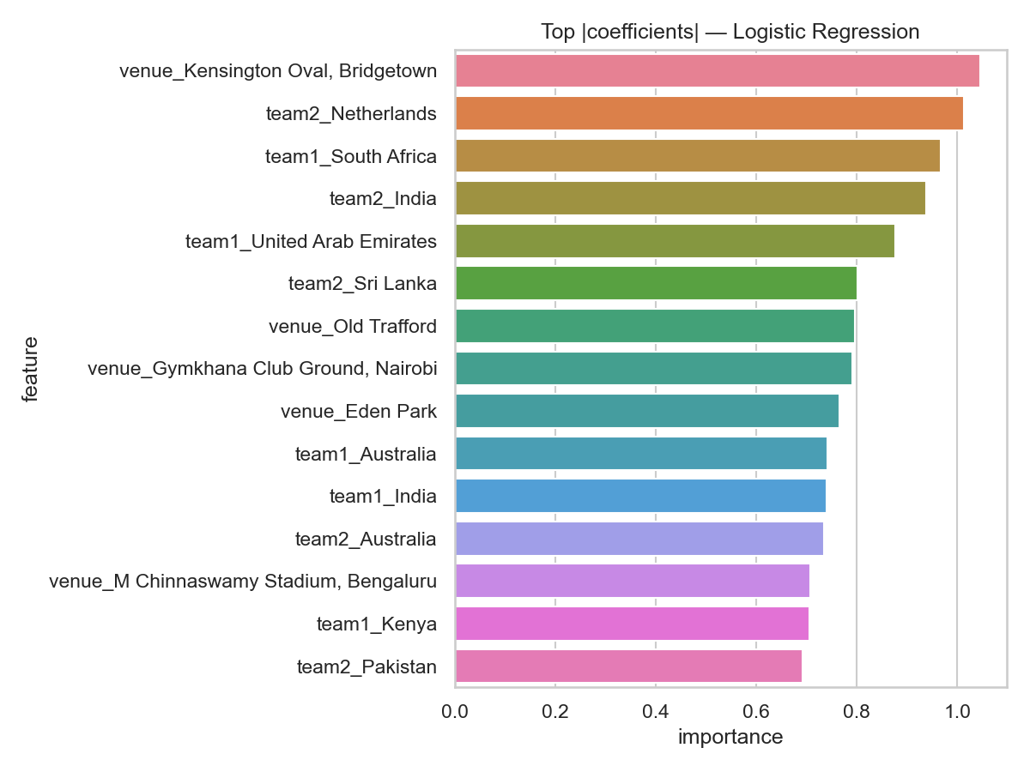

5. Discussion
Historical win rate difference (win_pct_diff) and head-to-head records are strong signals, which matches cricket intuition — stronger teams tend to keep winning. Toss effects appear weaker at World Cup level than in general ODIs, likely because teams are more evenly matched in knockout stages.
Limitations: sample size (~250 matches) is small for deep learning; features ignore player-level form, pitch report, and weather. Some eras have fewer matches, so early-year rolling stats default to 0.5.

6. Conclusion
We built an end-to-end pipeline from Cricsheet JSON to a deployed sklearn pipeline saved as best_model.pkl. Tree ensembles outperformed logistic regression, with ROC-AUC around 0.82. Future work could add squad strength, DLS adjustments, and separate models for group vs knockout stages.

